Credit Card Fraud Detection Using Decision Trees

Predictive Analytics

In this lesson we are going to outline the process of using a Decision Tree for credit card fraud detection. This lesson will begin with an outline of the data set that will be used during this process.

Dataset

When working with training any model, we first must begin with the training set. In this case we have a sample of data with four different attributes. Each of these attributes will play a part in the overall decisions that will be made. The most important of these is the status attribute which identifies if the transaction has been shown to be ​normal ​activity or ​fraud ​activity.
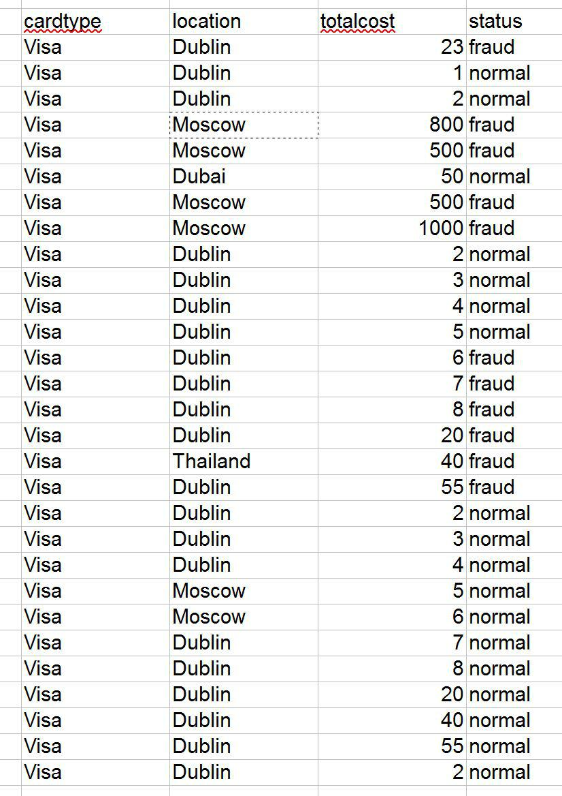
The data shown below is the ​test set​. These are the rows of data for each transaction which have yet to be identified as being fraud or normal activity. You will see that the status attribute in this set of data does not have any values yet. These are the values that we will be predicting.
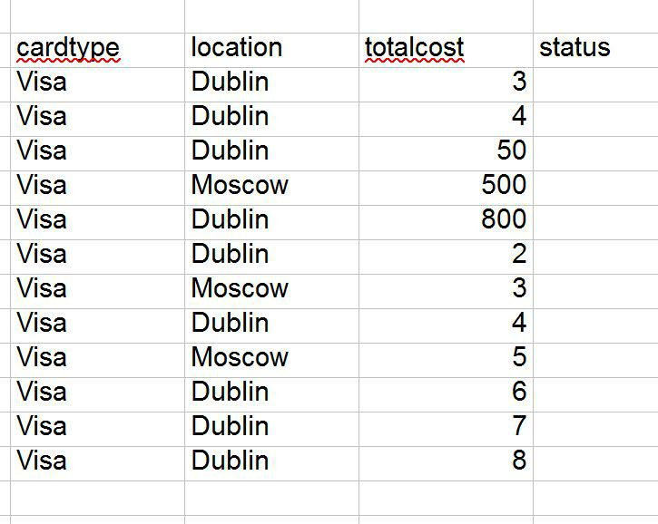
Setting up the operators

Similar to the previous less we must go through the process of getting the excel data into RapidMiner. To do this, we create two of the Read Excel operators.
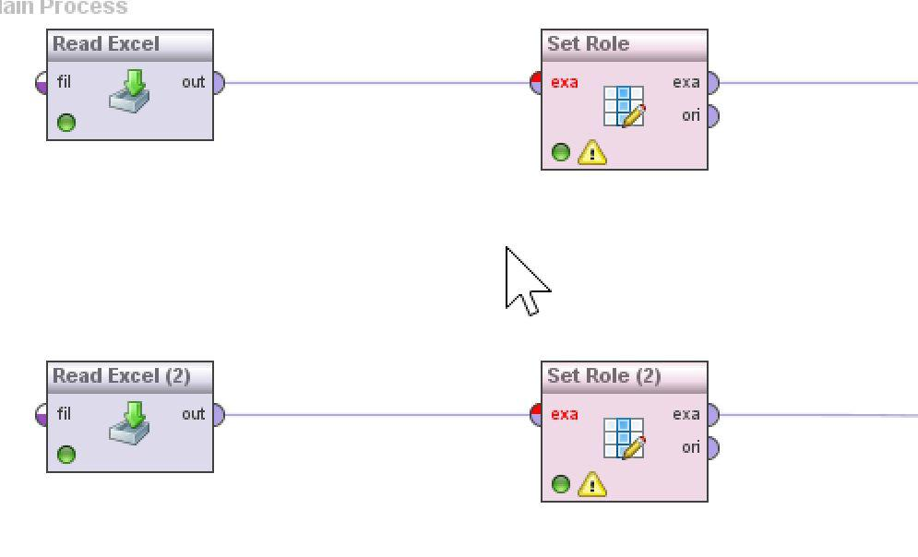
Click on each of the Read Excel operators and select the source of the first data set to be the training set and the second Read Excel will be used for reading in the Test Set.

As the first row in these documents are the names of the attributes it is important to ensure that we have selected the line “first row as names” to ensure the attribute names are retained and not treated as data.
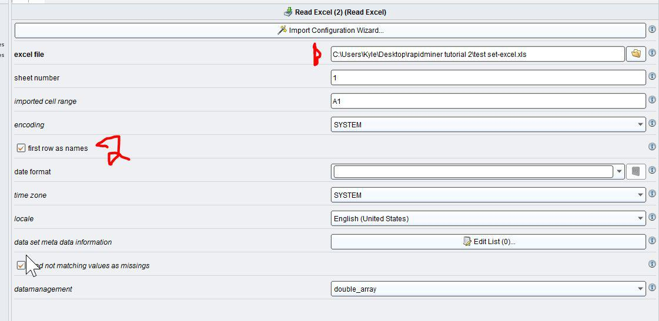
After the read excel operators have been added, next we must use to Set Role operators for each of the two datasets to tell RapidMiner which of the attributes it should focus on. In our case we are going to set the status attribute to be treated as the label for this dataset. Do this in both cases.
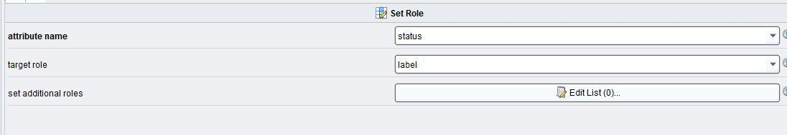

After we have added the Read Excel operator, the Set Role operators, we must then add the “select attribute” operator and add it into our chain. The purpose of this operator is to remove some or a single attribute from the dataset that we are not interested in and we do not want to impact or model. In this case we will select “single” and we are going to select a single attribute, and then we will specify the name of the attribute we want to remove. In this case we will remove the cardtype attribute.

If we stop now, the only attribute that will be used is the single attribute that we have specified. But we are interested in keeping every attribute and only removing this single attribute. To do this, we can select the “invert selection” box.
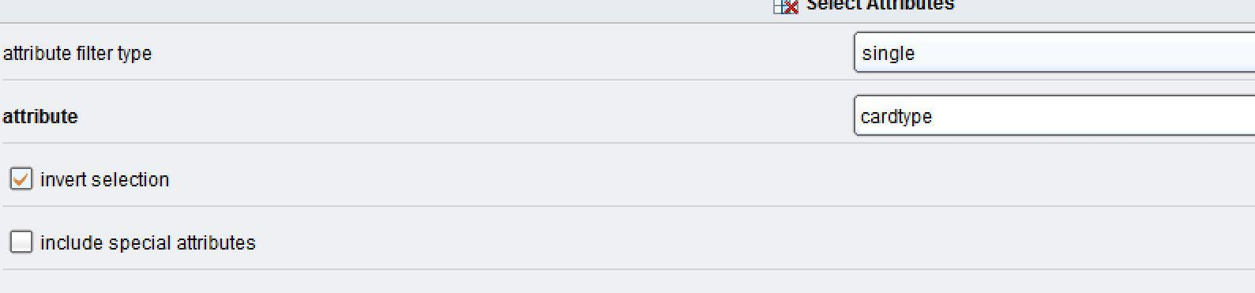
After we have done the above steps to prepare our data we can then move onto the next step which is adding the Decision Tree operator. After we have added this, we then must add an Apply Model operator, which is going to take in the training set and the decision tree and then apply it to our test set of data.

When you have finished your operator chain should look like the picture below. Remember to make a connection between the output of the Apply Model operator and connect it to the right hand side so we can see the output.
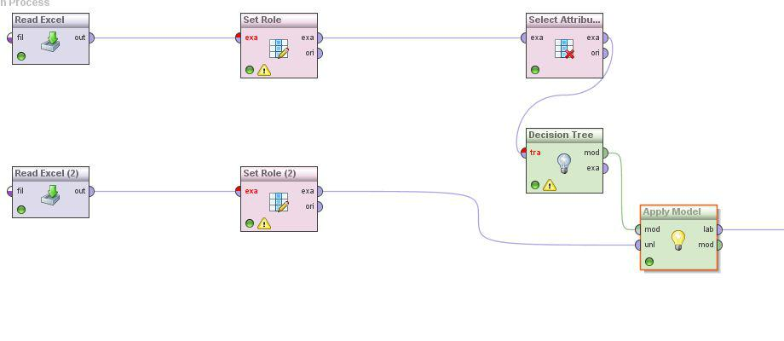

When all of you operators have been set up we can then go ahead and click on the play button which will begin the process of running the operators on the data that has been specified. This will then switch us across to the Results window.
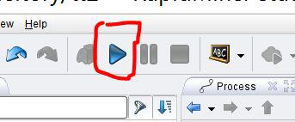
Viewing the results

After we have run this process we will then see the results. You will see that the original status column will be displayed to us, and as their is no data in this column a question mark will take the place of the data. The second attribute titled prediction gives us information about what value the Decision Tree has decided that the status column should have.

If we look across to the two yellow columns, we can see the confidence in the prediction it has made. When a 0 is shown, it indicates that it has no confidence, if the value is set to 1 it indicates that it has complete confidence. It is very typical to see a number in the range of 0.0 and 1.0 for this.
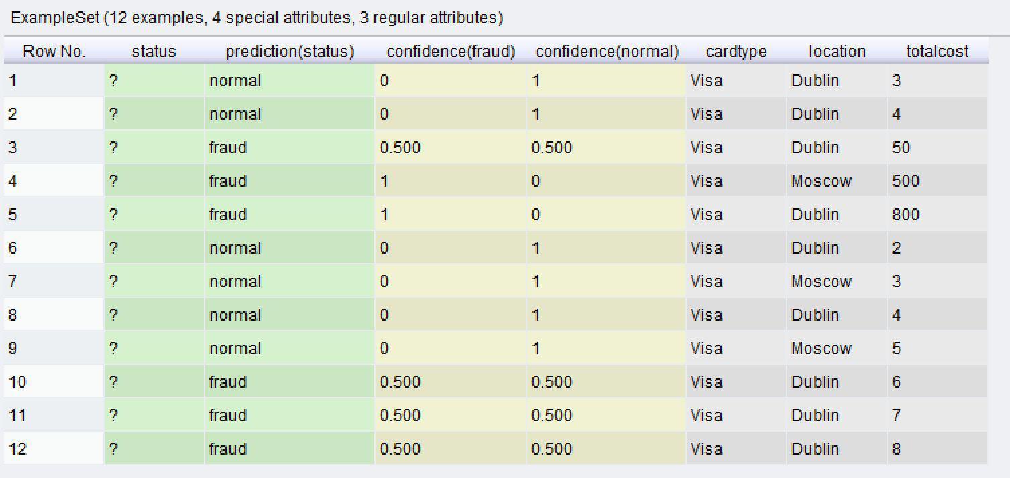

In this particular data set, the training set was very small so very little confidence was given to each of the predictions. Where a 0.5 is shown in both columns this indicates to us that we would need a bigger training set for better results.

Play around with the training set and change the values for the location and the totalcost attributes and see if you can encourage the algorithm to make better predictions. We are interested in getting around a 90% confidence on one side or another.

